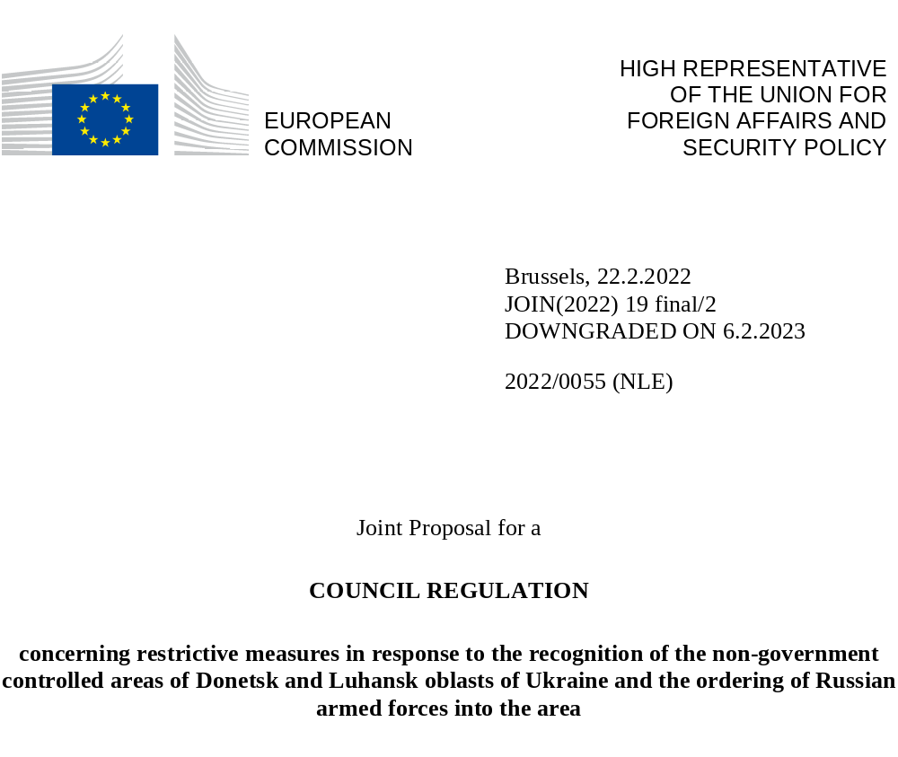

EXPLANATORY MEMORANDUM

(1) On XX February 2022, in response to the signing by the President of the Russian Federation of a decree recognising the “independence and sovereignty” of the non-government controlled areas of Donetsk and Luhansk oblasts of Ukraine and ordering the Russian armed forces into the area, the Council adopted Decision (CFSP) 2022/XXX [need the new title of the DECISION]
(2) Decision (CFSP) 2022/XXX imposes restrictions on goods originating in the specified territories and on the provision, directly or indirectly, of financing or financial assistance, as well as insurance and reinsurance, related to the import of such goods, with the exception of goods having been granted a certificate of origin by the Government of Ukraine.
(3) In addition, Decision (CFSP) 2022/XXX restricts trade in goods and technology for use in certain sectors in the specified territories, and prohibits services in the sectors of transport, telecommunications, energy or the prospection, exploration and production of oil, gas and mineral resources, as well as services related to tourism activities in the specified territories.
(4) These measures fall within the scope of the Treaty and, therefore, notably with a view to ensuring their uniform application in all Member States, regulatory action at the level of the Union is necessary in order to implement them.
(5) The High Representative of the Union for Foreign Affairs and Security Policy and the European Commission should make a proposal for a Regulation concerning restrictive measures in response to the recognition of the non-government controlled areas of Donetsk and Luhansk oblasts of Ukraine and the ordering of Russian armed forces into the area.

2022/0055 (NLE)
Joint Proposal for a
COUNCIL REGULATION
concerning restrictive measures in response to the recognition of the non-government controlled areas of Donetsk and Luhansk oblasts of Ukraine and the ordering of Russian armed forces into the area
THE COUNCIL OF THE EUROPEAN UNION,
Having regard to the Treaty on the Functioning of the European Union, and in particular Article 215 thereof,
Having regard to Decision (CFSP) 2022/XXX of XX February 2022 concerning restrictive measures in response to the recognition of the non-government controlled areas of Donetsk and Luhansk oblasts of Ukraine and the ordering of Russian armed forces into the area,
Having regard to the joint proposal of the High Representative of the Union for Foreign Affairs and Security Policy and of the European Commission,
Whereas:
(1) On XX February 2022, in response to the signing by the President of the Russian Federation of a decree recognising the “independence and sovereignty” of the non-government controlled areas of Donetsk and Luhansk oblasts of Ukraine and ordering the Russian armed forces into the area, the Council adopted Decision (CFSP) 2022/XXX [new title]
(2) Decision (CFSP) 2022/XXX imposes restrictions on goods originating in the specified territories and on the provision, directly or indirectly, of financing or financial assistance, as well as insurance and reinsurance, related to the import of such goods, with the exception of goods having been granted a certificate of origin by the Government of Ukraine.
(3) In addition, Decision (CFSP) 2022/XXX restricts trade in goods and technology for use in certain sectors in the specified territories, and prohibits services in the sectors of transport, telecommunications, energy or the prospection, exploration and production of oil, gas and mineral resources, as well as services related to tourism activities in the specified territories.
(4) In order to ensure uniform conditions for the implementation of this Regulation, implementing powers should be conferred on the Commission.
(5) Member States and the Commission should inform each other of the measures taken pursuant to this Regulation and of other relevant information at their disposal in connection with this Regulation.
(6) Member States should lay down rules on penalties applicable to infringements of the provisions of this Regulation and make sure that they are implemented. Those penalties should be effective, proportionate and dissuasive.
(7) These measures fall within the scope of the Treaty and, therefore, notably with a view to ensuring their uniform application in all Member States, regulatory action at the level of the Union is necessary in order to implement them.
(8) In order to ensure that the measures provided for in this Regulation are effective, it should enter into force on the day following that of its publication,
HAS ADOPTED THIS REGULATION:
Article 1
For the purposes of this Regulation, the following definitions apply:
(a) ‘brokering services’ means:
(i) the negotiation or arrangement of transactions for the purchase, sale or supply of goods and technology or of financial and technical services, including from a third country to any other third country; or
(ii) the selling or buying of goods and technology or of financial and technical services, including where they are located in third countries for their transfer to another third country;
(b) ‘claim’ means any claim, whether asserted by legal proceedings or not, made before or after [date of entry into force], under or in connection with a contract or transaction, and includes in particular:
(i) a claim for performance of any obligation arising under or in connection with a contract or transaction;
(ii) a claim for extension or payment of a bond, financial guarantee or indemnity of whatever form;
(iii) a claim for compensation in respect of a contract or transaction;
(iv) a counterclaim;
(v) a claim for the recognition or enforcement, including by the procedure of exequatur, of a judgment, an arbitration award or an equivalent decision, wherever made or given;
(c) ‘contract or transaction’ means any transaction of whatever form, whatever the applicable law, and whether comprising one or more contracts or similar obligations made between the same or different parties; for this purpose ‘contract’ includes a bond, guarantee or indemnity, particularly a financial guarantee or financial indemnity, and credit, whether legally independent or not, as well as any related provision arising under, or in connection with, the transaction;
(d) ‘specified territories’ means the non-government controlled areas of the Donetsk and Luhansk oblasts of Ukraine subject to aggression;
(e) ‘entity in the specified territories’ means any entity having its registered office, central administration or principal place of business in the specified territories, its subsidiaries or affiliates under its control in the specified territories, as well as branches and other entities operating in the specified territories;
(f) ‘goods originating in the specified territories’ means goods which are wholly obtained in the specified territories or which have undergone their last substantial transformation there, in accordance, mutatis mutandis, with Article 60 of Regulation (EU) No 952/2013 of the European Parliament and of the Council of 9 October 2013 laying down the Union Customs Code;
(g) ‘investment services’ means the following services and activities:
(i) reception and transmission of orders in relation to one or more financial instruments,
(ii) execution of orders on behalf of clients,
(iii) dealing on own account,
(iv) portfolio management,
(v) investment advice,
(vi) underwriting of financial instruments and/or placing of financial instruments on a firm commitment basis,
(vii) placing of financial instruments without a firm commitment basis,
(h) ‘technical assistance’ means any technical support related to repairs, development, manufacture, assembly, testing, maintenance, or any other technical service, and may take forms such as instruction, advice, training, transmission of working knowledge or skills or consulting services; technical assistance includes verbal forms of assistance;
(i) ‘territory of the Union’ means the territories of the Member States to which the Treaty is applicable, under the conditions laid down in the Treaty, including their airspace;
(j) ‘competent authorities’ means the competent authorities of the Member States as identified on the websites listed in Annex I;
Article 2
1. It shall be prohibited:
(a) to import into the European Union goods originating in the specified territories;
(b) to provide, directly or indirectly, financing or financial assistance as well as insurance and reinsurance related to the import of the goods referred to in point (a).
2. The prohibitions in paragraph 1 shall not apply in respect of:
(a) the execution until [three months after entry into force] of trade contracts concluded before [entry into force], or of ancillary contracts necessary for the execution of such contracts, provided that the natural or legal persons, entity or body seeking to perform the contract have notified, at least 10 working days in advance, the activity or transaction to the competent authority of the Member State in which they are established.
(b) goods originating in the specified territories which have been made available to the Ukrainian authorities for examination, for which compliance with the conditions conferring entitlement to preferential origin has been verified and for which a certificate of origin has been issued in accordance with the EU-Ukraine Association Agreement.
Article 3
1. It shall be prohibited to:
(c) acquire any new or extend any existing participation in ownership of real estate located in the specified territories;
(d) acquire any new or extend any existing participation in ownership or control of an entity in the specified territories, including the acquisition in full of such entity or the acquisition of shares, and other securities of a participating nature of such entity;
(e) grant or be part of any arrangement to grant any loan or credit or otherwise provide financing, including equity capital, to an entity in the specified territories, or for the documented purpose of financing such entity;
(f) create any joint venture in the specified territories or with an entity in the specified territories;
(g) provide investment services directly related to the activities referred to in points (a) to (d).
2. The prohibitions and restrictions in this Article do not apply to the conduct of legitimate business with entities outside the specified territories where the related investments are not destined to entities in the specified territories.
3. The prohibitions in paragraph 1 shall be without prejudice to the execution of an obligation arising from a contract concluded before [entry into force], or ancillary contracts necessary for the execution of such a contract, provided that the competent authority has been informed at least five working days in advance.
Article 4
1. It shall be prohibited to sell, supply, transfer, or export goods and technology as listed in Annex II:
(a) to any natural or legal person, entity or body in the specified territories, or
(b) for use in the specified territories.
Annex II shall include certain goods and technologies suited for use in the following key sectors:
(i) transport;
(ii) telecommunications;
(iii) energy;
(iv) the prospection, exploration and production of oil, gas and mineral resources.
2. It shall be prohibited to:
(a) provide, directly or indirectly, technical assistance or brokering services related to the goods and technology as listed in Annex II, or related to the provision, manufacture, maintenance and use of such items to any natural or legal person, entity or body in the specified territories or for use in the specified territories;
(b) provide, directly or indirectly, financing or financial assistance related to the goods and technology as listed in Annex II to any natural or legal person, entity or body in the specified territories or for use in the specified territories.
3. The prohibitions in paragraphs 1 and 2 shall be without prejudice to the execution until [three months after entry into force] of an obligation arising from a contract concluded before [entry into force], or by ancillary contracts necessary for the execution of such contracts, provided that the competent authority has been informed at least five working days in advance.
Article 5
1. It shall be prohibited to provide technical assistance, or brokering, construction or engineering services directly relating to infrastructure in the specified territories in the sectors referred to in Article 4(1) as defined on the basis of Annex II, independently of the origin of the goods and technology.
2. The prohibition in paragraph 1 shall be without prejudice to the execution until [three months after entry into force] of an obligation arising from a contract concluded before [entry into force], or by ancillary contracts necessary for the execution of such a contract.
3. It shall be prohibited to participate, knowingly or intentionally, in activities the object or effect of which is to circumvent the prohibitions referred to in paragraphs 1 and 2.
Article 6
1. It shall be prohibited to provide services directly related to tourism activities in the specified territories.
2. The prohibition in paragraph 1 shall be without prejudice to the execution until [three months after entry into force] of an obligation arising from a contract or an ancillary contract concluded before [entry into force], or ancillary contracts necessary for the execution of such contracts, provided that the competent authority has been informed at least five working days in advance.
Article 7
1. The competent authorities may grant, under such terms and conditions as they deem appropriate, an authorisation in relation to the activities referred to in Article 3(1) and Article 4(2), and to the goods and technology referred to in Article 4(1) provided that they are
(a) necessary for official purposes of consular missions or international organisations enjoying immunities in accordance with international law located in the specified territories;
(b) related to projects exclusively in support of hospitals, or other public health institutions providing medical services or civilian education establishments located in the specified territories; or
(c) appliances or equipment for medical use.
2. The competent authorities may also grant, under such terms and conditions as they deem appropriate, an authorisation in relation to the activities referred to in Article 3(1), provided that the transaction is for the purpose of the maintenance in order to ensure safety of existing infrastructure.
3. The competent authorities may also grant, under such terms and conditions as they deem appropriate, an authorisation in relation to the activities referred to in Article 3(1) and in Article 4(2), and to the goods and technology referred to in Article 4(1) and to the services referred to in Article 5, where the sale, supply, transfer or export of the items or the carrying out of those activities is necessary for the urgent prevention or mitigation of an event likely to have a serious and significant impact on human health and safety, including the safety of existing infrastructure, or the environment. In duly justified cases of emergency, the sale, supply, transfer or export may proceed without prior authorisation, provided that the exporter notifies the competent authority within five working days after the sale, supply, transfer or export has taken place, providing detail about the relevant justification for the sale, supply, transfer or export without prior authorisation.
The Commission and the Members States shall inform each other of the measures taken under this paragraph and share any other relevant information at their disposal.
Article 8
It shall be prohibited to participate, knowingly and intentionally, including indirectly, in activities the object or effect of which is to circumvent the prohibitions laid down in this Regulation.
Article 9
Actions by natural or legal persons, entities or bodies shall not give rise to any liability of any kind on their part if they did not know, and had no reasonable cause to suspect, that their actions would infringe the measures set out in this Regulation.
Article 10
1. No claims in connection with any contract or transaction the performance of which has been affected, directly or indirectly, in whole or in part, by the measures imposed under this Regulation, including claims for indemnity or any other claim of this type, such as a claim for compensation or a claim under a guarantee, particularly a claim for extension or payment of a bond, guarantee or indemnity, particularly a financial guarantee or financial indemnity, of whatever form, shall be satisfied, if they are made by:
(a) designated natural or legal persons, entities or bodies listed in Annex I to Council Regulation (EU) No 269/2014;
(b) any natural or legal person, entity or body acting through or on behalf of one of the persons, entities or bodies referred to in point (a);
(c) any natural or legal person, entity or body which has been found by an arbitral, judicial or administrative decision to have infringed the prohibitions set out in this Regulation;
(d) any natural or legal person, entity or body, if the claim relates to goods the import of which is prohibited under Article 2(1).
2. In any proceedings for the enforcement of a claim, the onus of proving that satisfying the claim is not prohibited by paragraph 1 shall be on the natural or legal person, entity or body seeking the enforcement of that claim.
3. This Article is without prejudice to the right of natural or legal persons, entities or bodies referred to in paragraph 1 to judicial review of the legality of the non-performance of contractual obligations in accordance with this Regulation.
Article 11
1. The Commission and the Member States shall inform each other of the measures taken under this Regulation and share any other relevant information at their disposal in connection with this Regulation, in particular information in respect of violation and enforcement problems and judgments handed down by national courts.
2. The Member States shall immediately inform each other and the Commission of any other relevant information at their disposal which might affect the effective implementation of this Regulation.
Article 12
1. Member States shall lay down the rules on penalties applicable to infringements of the provisions of this Regulation and shall take all measures necessary to ensure that they are implemented. The penalties provided for must be effective, proportionate and dissuasive.
2. Member States shall notify the rules referred to in paragraph 1 to the Commission without delay after the entry into force of this Regulation and shall notify it of any subsequent amendment.
Article 13
1. Member States shall designate the competent authorities referred to in this Regulation and identify them on the websites listed in Annex I. Member States shall notify the Commission of any changes in the addresses of their websites listed in Annex I.
2. Member States shall notify the Commission of their competent authorities, including the contact details of those competent authorities, without delay after the entry into force of this Regulation, and shall notify it of any subsequent amendment.
3. Where this Regulation sets out a requirement to notify, inform or otherwise communicate with the Commission, the address and other contact details to be used for such communication shall be those indicated in Annex I.
Article 14
This Regulation shall apply:
(a) within the territory of the Union, including its airspace;
(b) on board any aircraft or any vessel under the jurisdiction of a Member State;
(c) to any person inside or outside the territory of the Union who is a national of a Member State;
(d) to any legal person, entity or body, inside or outside the territory of the Union, which is incorporated or constituted under the law of a Member State;
(e) to any legal person, entity or body in respect of any business done in whole or in part within the Union.
Article 15
This Regulation shall enter into force on the day following that of its publication in the Official Journal of the European Union.
This Regulation shall be binding in its entirety and directly applicable in all Member States.
Done at Brussels,
For the Council
The President

OJ L , , p. .
OJ L

